NOTE: The submitted document should contain each question, followed by text version of code, the screenshot of the code, followed by screenshot of the results. The submitted document should also contain your name, course number, course name. Submit everything in one single document. Name your file according to this convention: INFO531/ISTA431_Week13_Lastname.

1. First, create a DataFrame out of a CSV file downloading from the open data source, Kaggle [https://www.kaggle.com/datasets] or UCI Machine Learning Repository [https://archive.ics.uci.edu/ml/datasets.php]. Make sure the CSV file contains a date field and a numeric field, at least. Please provide the link to your data file as part of your assignment submission. Next, remove one or two unwanted columns and rows from the DataFrame with the drop() function.
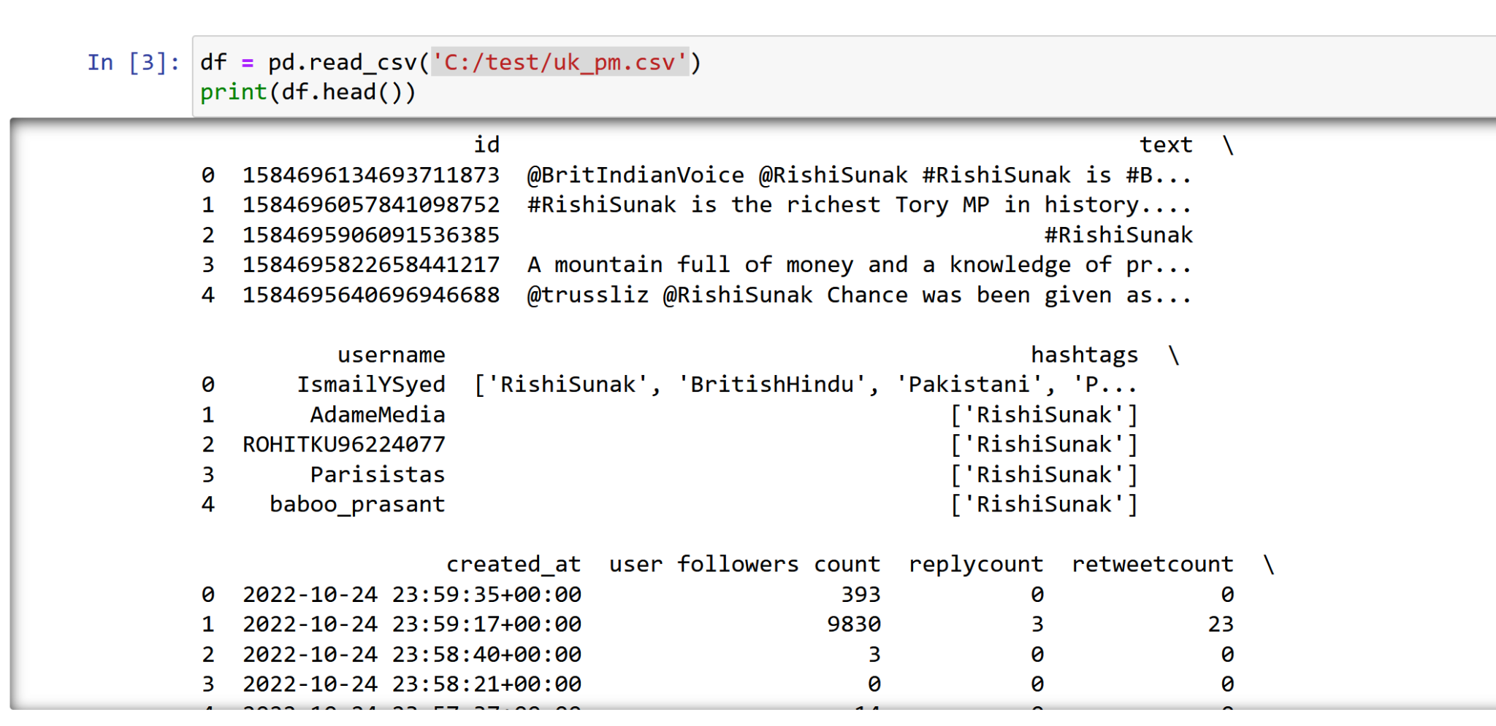
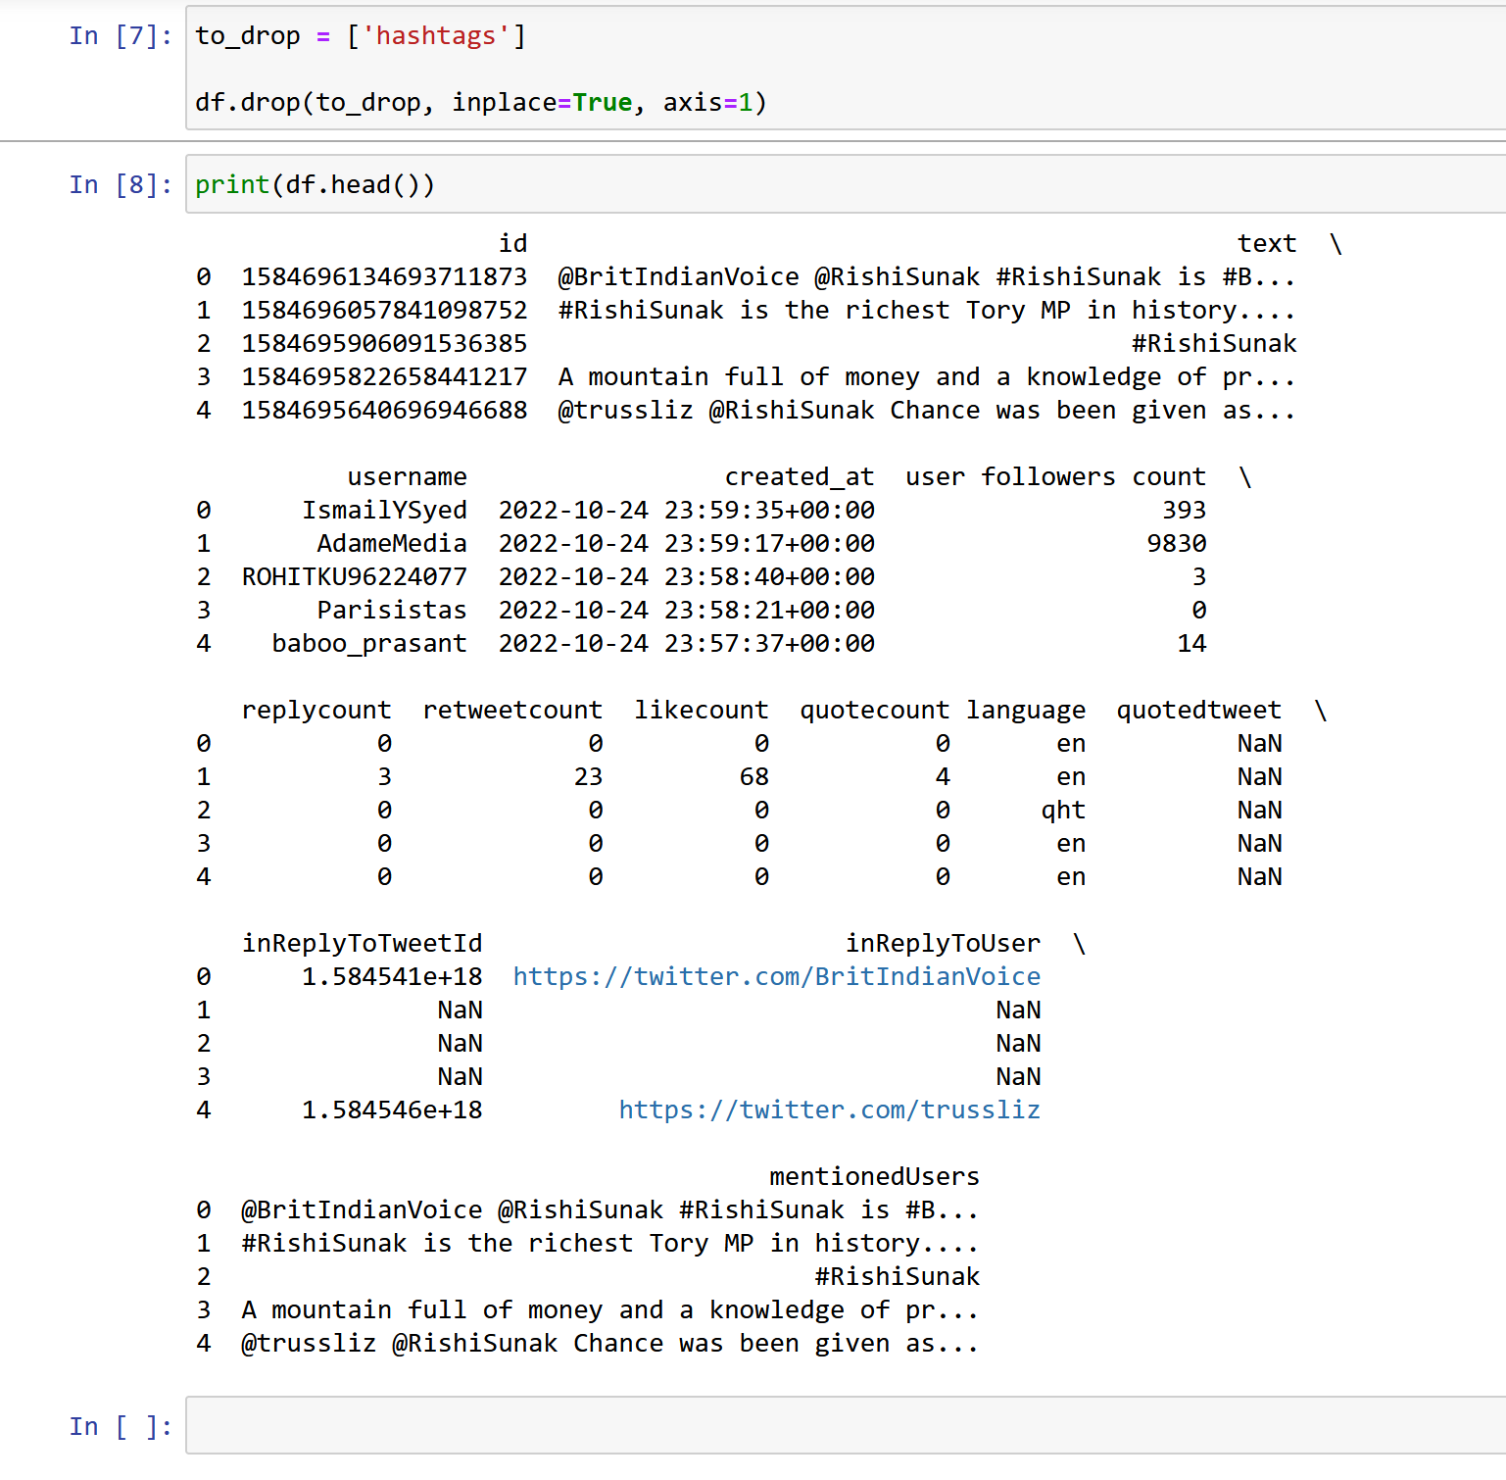
2. You have created an instance of Pandas DataFrame in #1 above. Now, change the Index of a DataFrame based on uniquely valued identifying field using set_index by setting the inplace parameter.
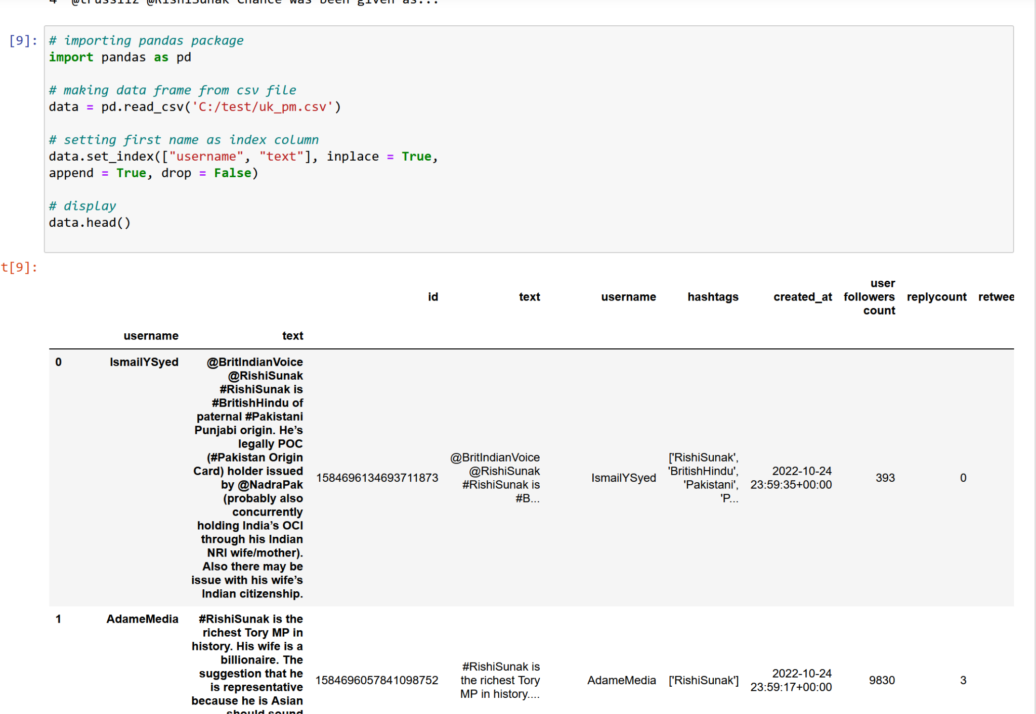
3. You have created an instance of Pandas DataFrame in #1 above. Now extract the year from the date field. Then convert it to an integer field by using the to_numeric function. Print the data type for the newly converted date field.
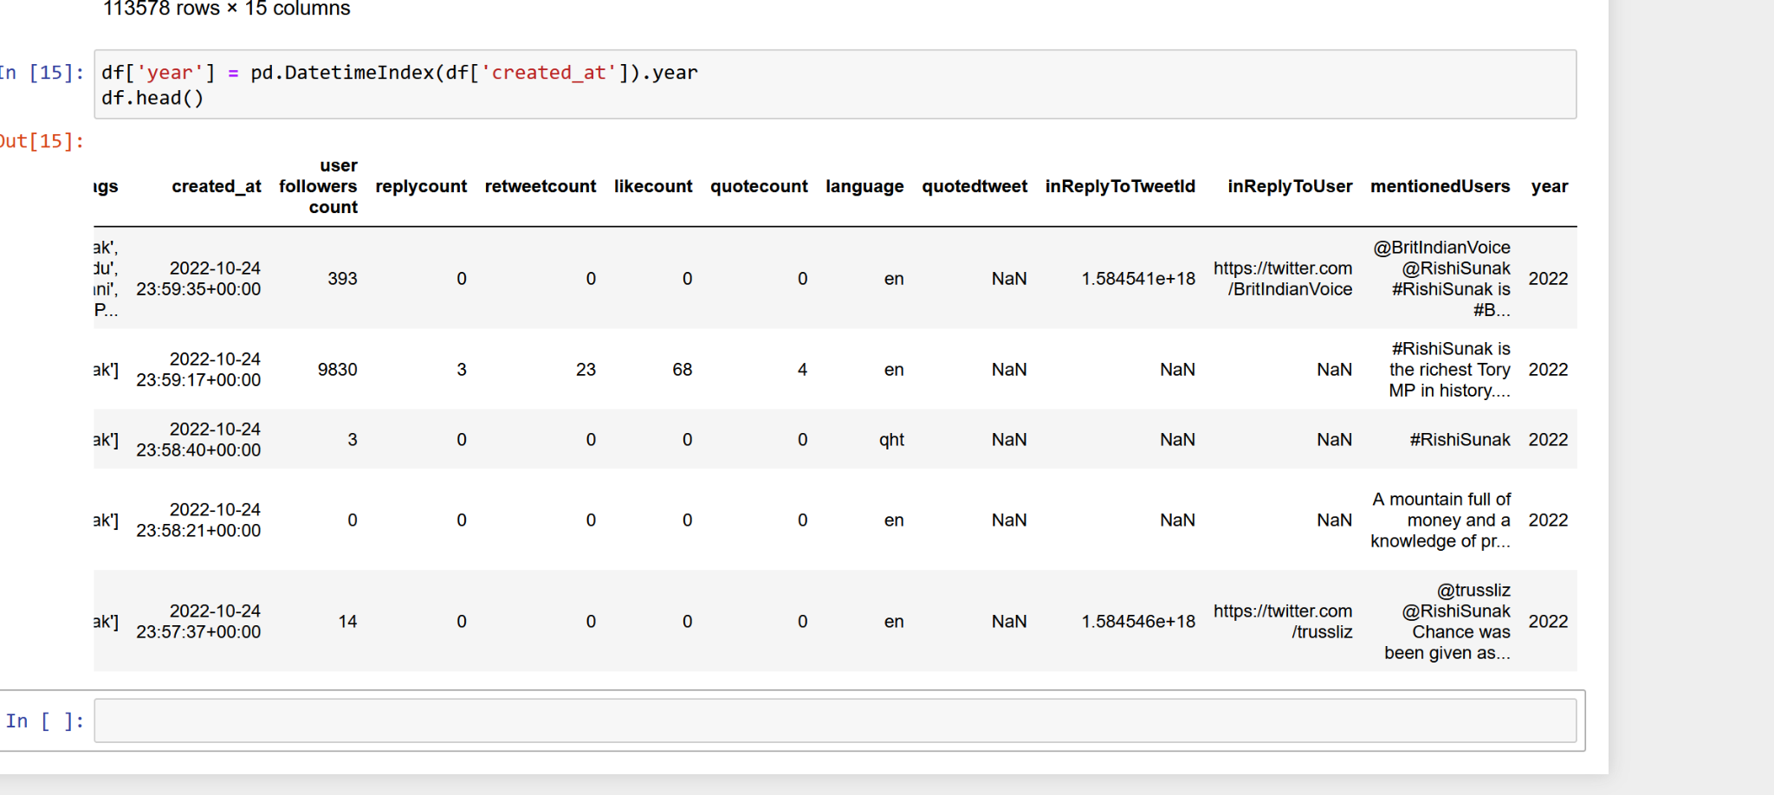
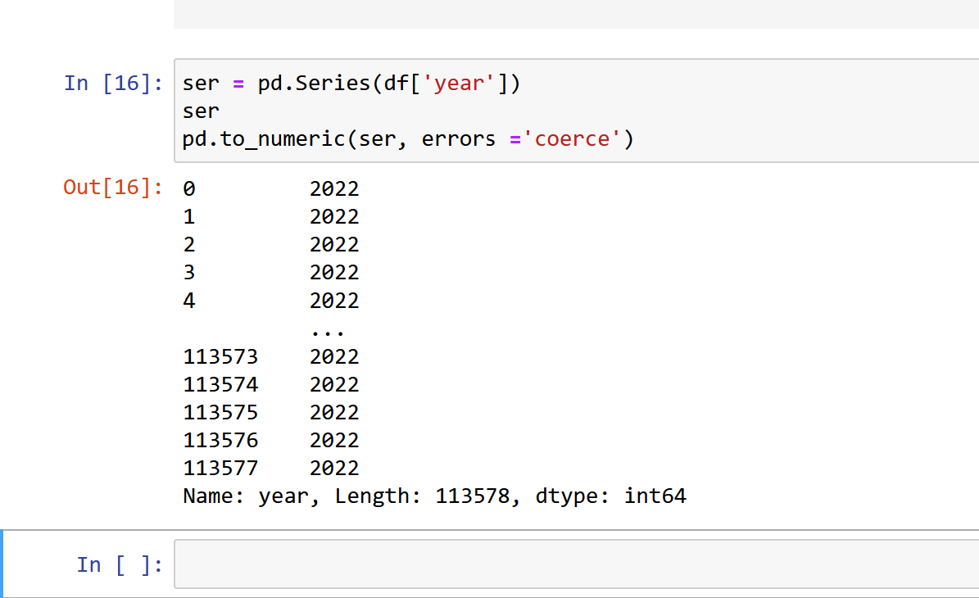
4. You have created an instance of Pandas DataFrame in #1 above. Append a row to the dataframe using a Python dictionary. Reset the row index after the concatenation.
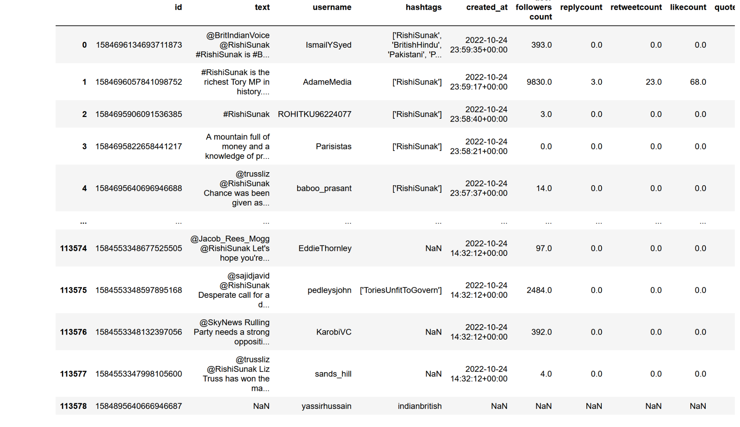
5. You have created an instance of Pandas DataFrame in #1 above. Check for missing values of a particular column using isnull() function. Show the results.
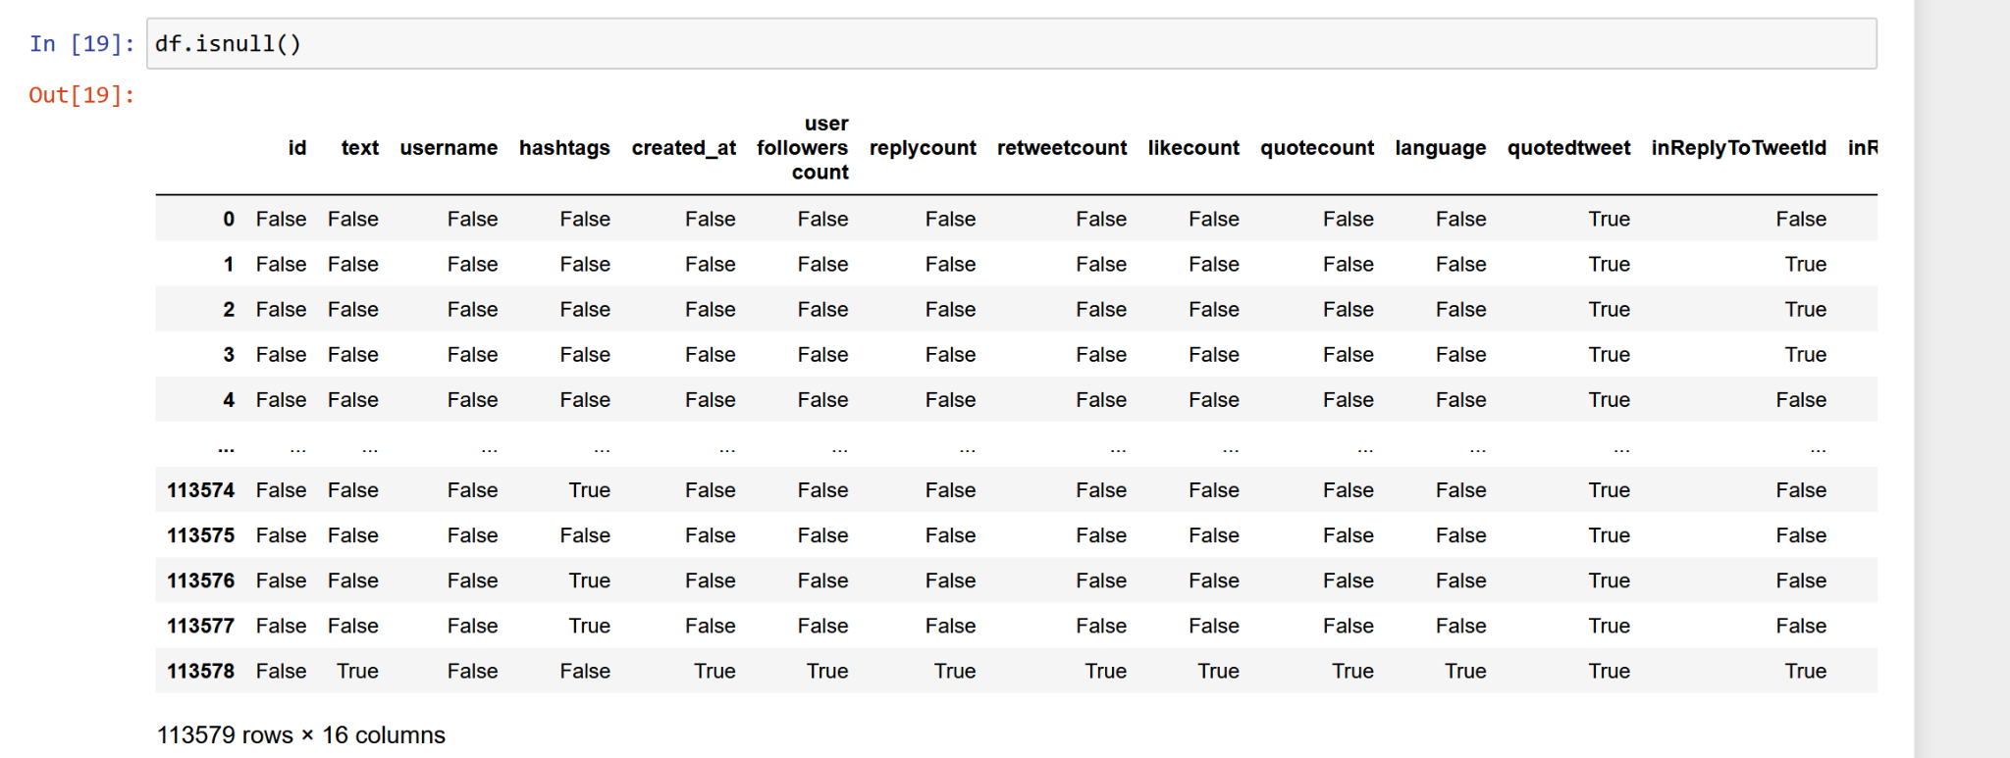
6. You have created an instance of Pandas DataFrame in #1 above. Now, drop rows with column value null using data.dropna function.
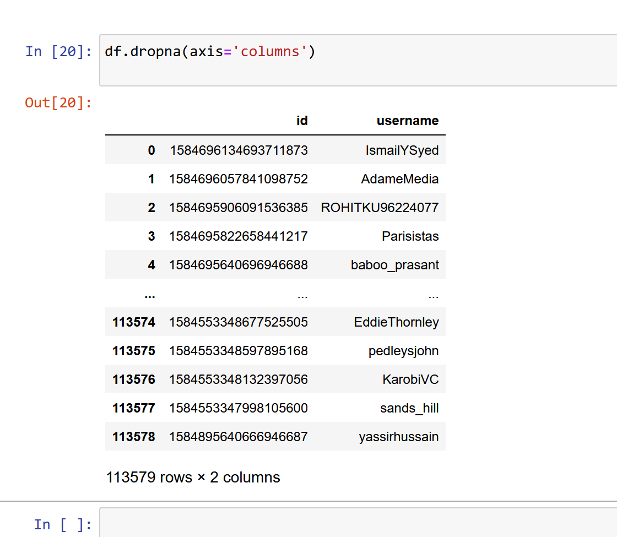
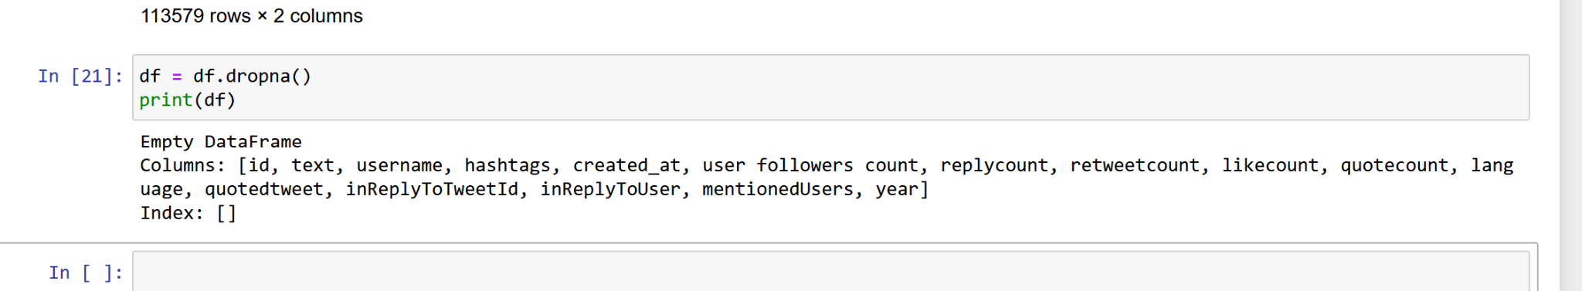
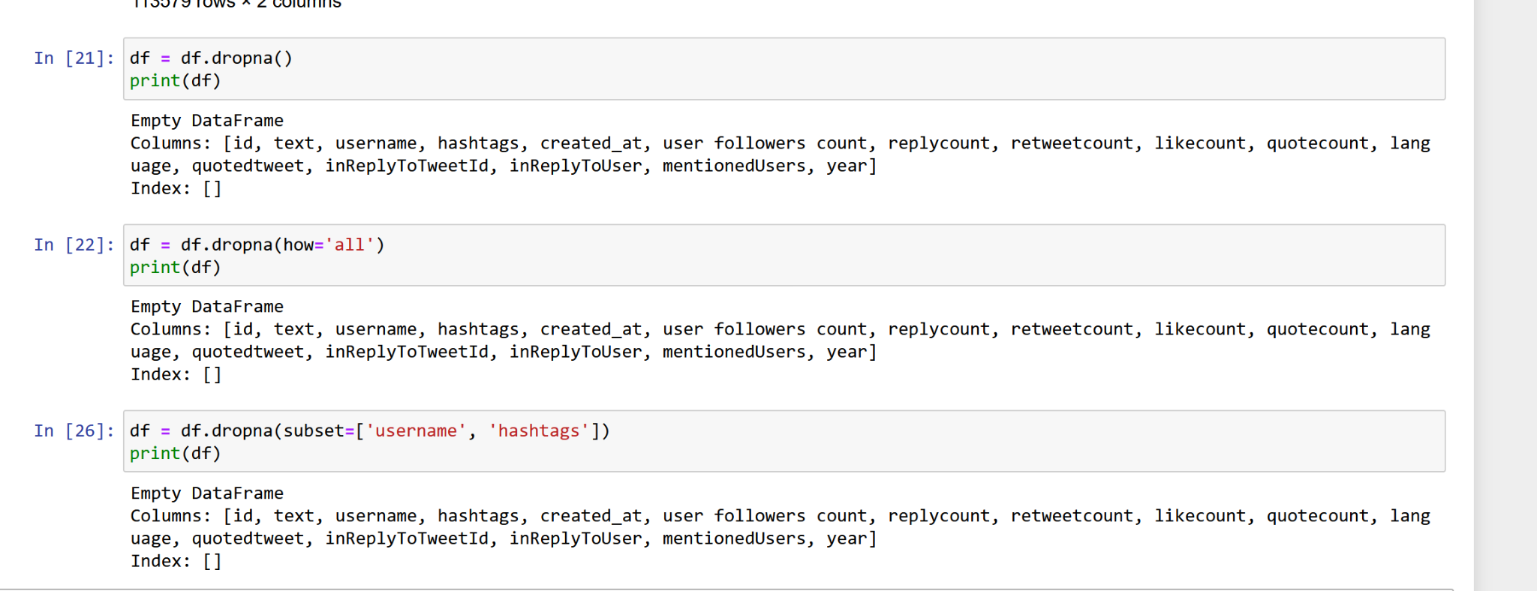
7. You have created an instance of Pandas DataFrame in #1 above. Select and print a subset of both rows and columns using the loc/iloc operators.
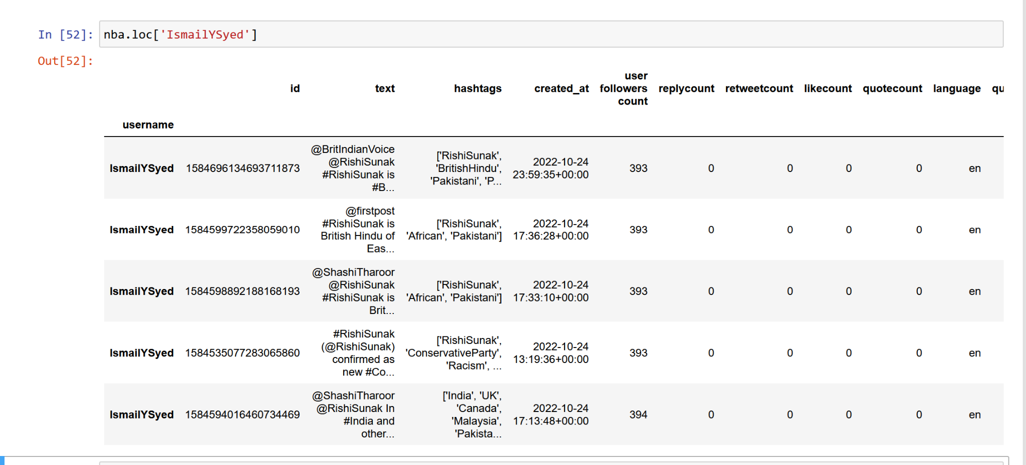
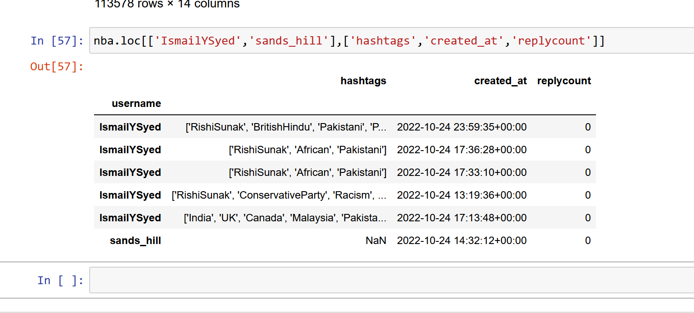
8. Find missing data by using count_nonzero function from NumPy in conjunction with the isnull method.
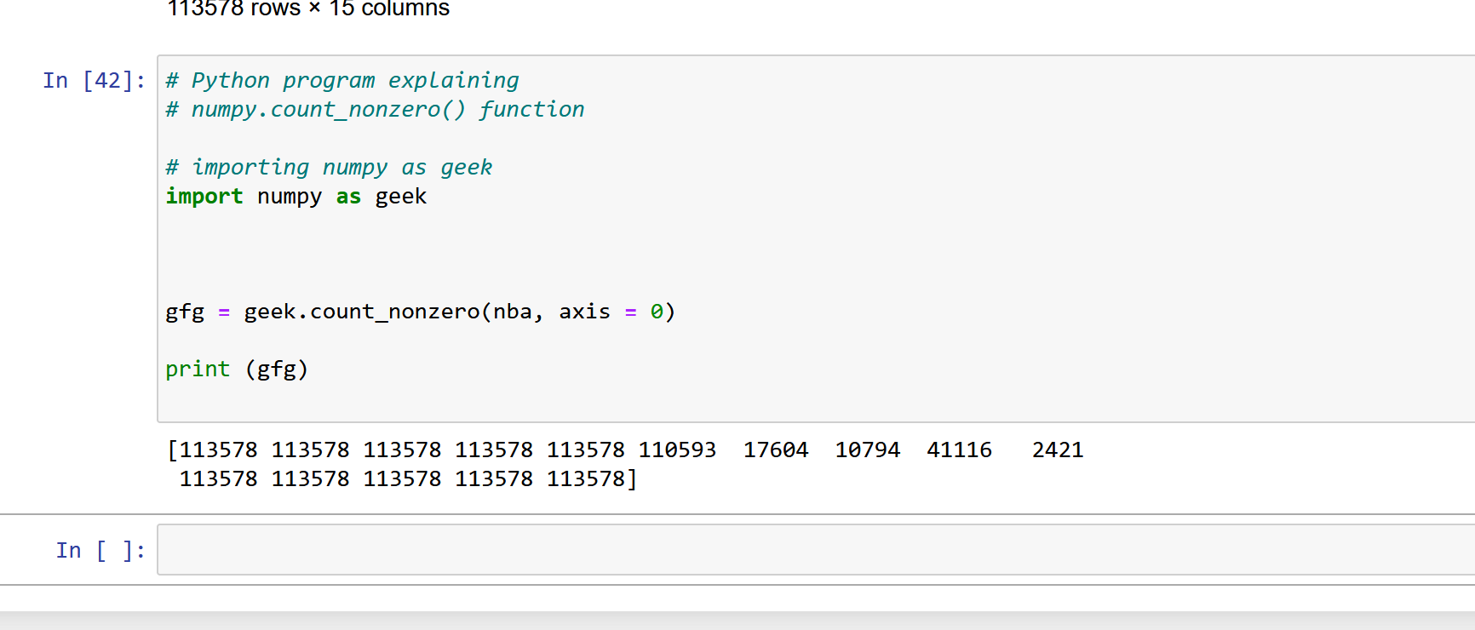
9. Recode the missing values as a 0 or NA using fillna() for a particular column. Display the data.
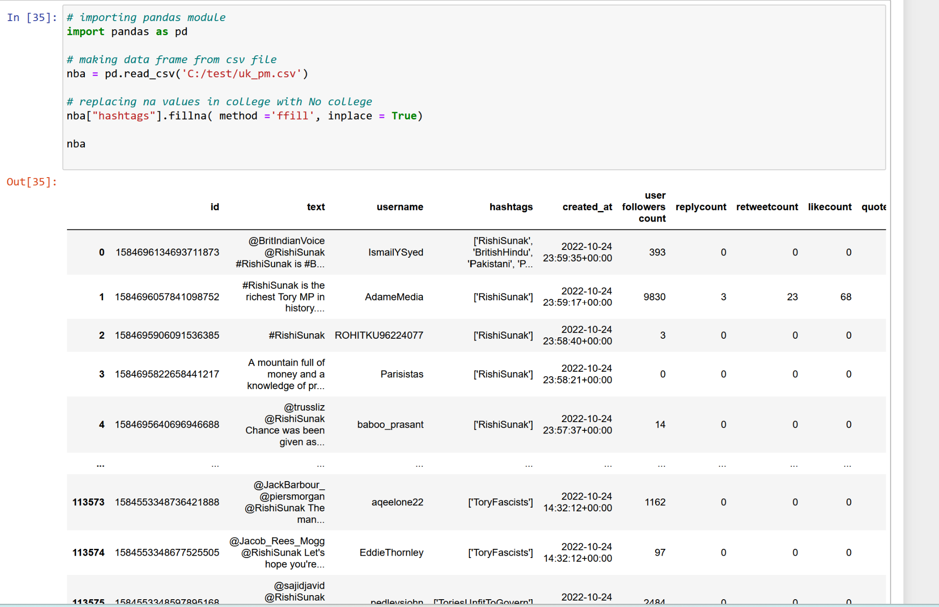
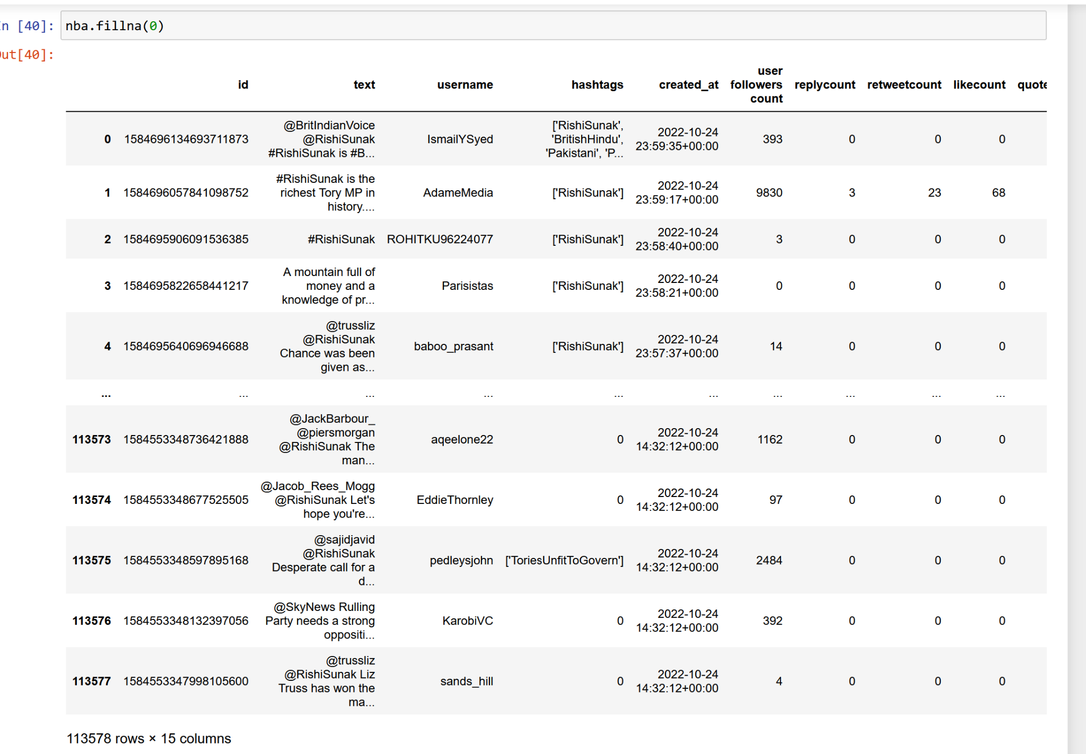
10. ROT is a very simple cipher that is used to information hiding (https://en.wikipedia.org/wiki/ROT13). Read the wiki page to understand how the encoder works.

Create an "encode_rot()" function to encode any given strings using ROT algorithm.
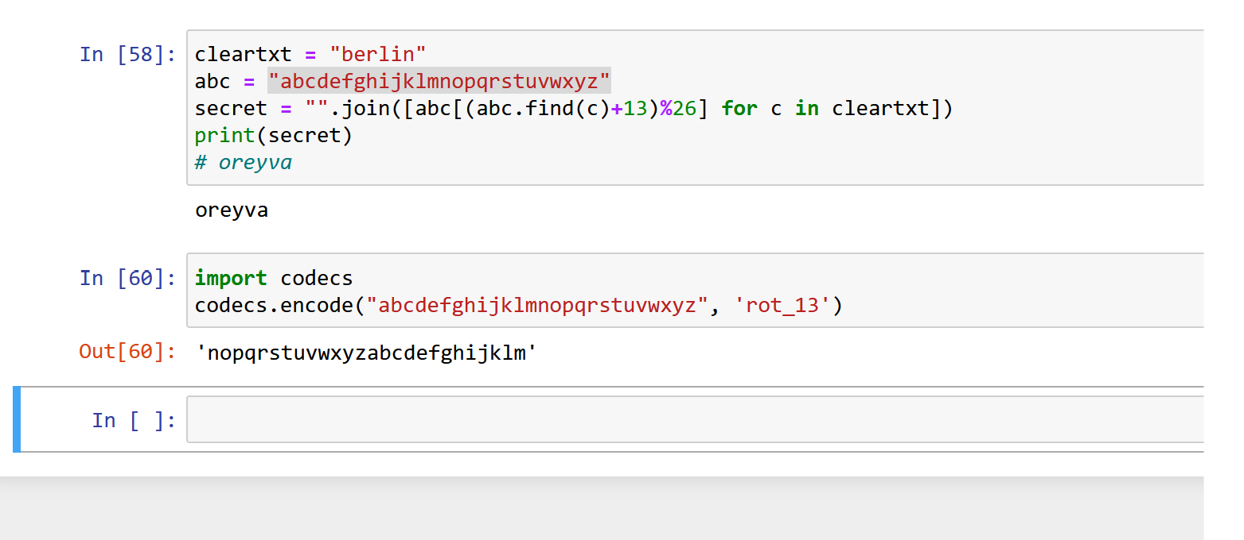
The input should contain a key and a string of text. The key can be any integers both negative and positive (-12: turn left 12 positions, 36: turn right 36 positions). Only alphabet letters are encoded.

The following two lines of your code will generate an output of "Ocejkpg ECP ngctp 2 !!!".

clear_text= " Machine CAN learn 2 !!!"
encode_rot(clear_text, 28)

End
2

